IT 236 Project Report Form
Report Prepared By: | Vivian John Goshashy
Date: | 11/26/2025
Project Phase | Mobile Device Management

Section 1: Executive Summary
During this phase of the NewVue Health Infrastructure Modernization Project, cloud-based device management capabilities were introduced through Microsoft Intune.
Building on the previously established hybrid identity foundation, NV-CLI was successfully enrolled into Intune and brought under centralized cloud management.
This enabled the deployment of Microsoft 365 applications, the application of compliance and security baselines, and the configuration of controlled update management policies.
Verification activities confirmed successful Hybrid Azure AD Join, active Intune enrollment, and the application of cloud-delivered policies and configurations.
Collectively, this work demonstrates how modern endpoint management extends from on-premises Active Directory into cloud-native tools, enabling consistent security governance, software deployment, and operational visibility across the organization’s Windows devices.

Section 2: Implementation & Verification Evidence

Task 1- Automatic Intune Enrollment Configuration (15 pts)
A configuration policy was created to ensure that domain-joined devices are automatically enrolled into Intune during Hybrid Azure AD Join. This step ensures seamless onboarding of corporate Windows endpoints into the organization’s cloud management environment.
Required Evidence
- Evidence 1: Screenshot showing MDM user scope set to All in Intune.
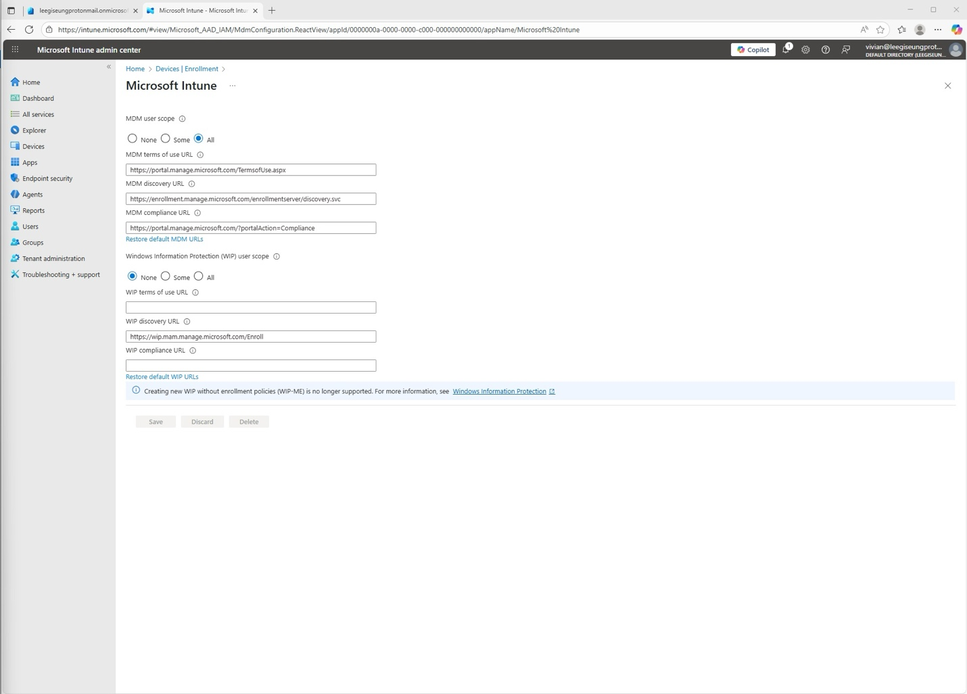

- Evidence 2: Screenshot of the GPO “Enable automatic MDM enrollment using default Azure AD credentials” set to Enabled.
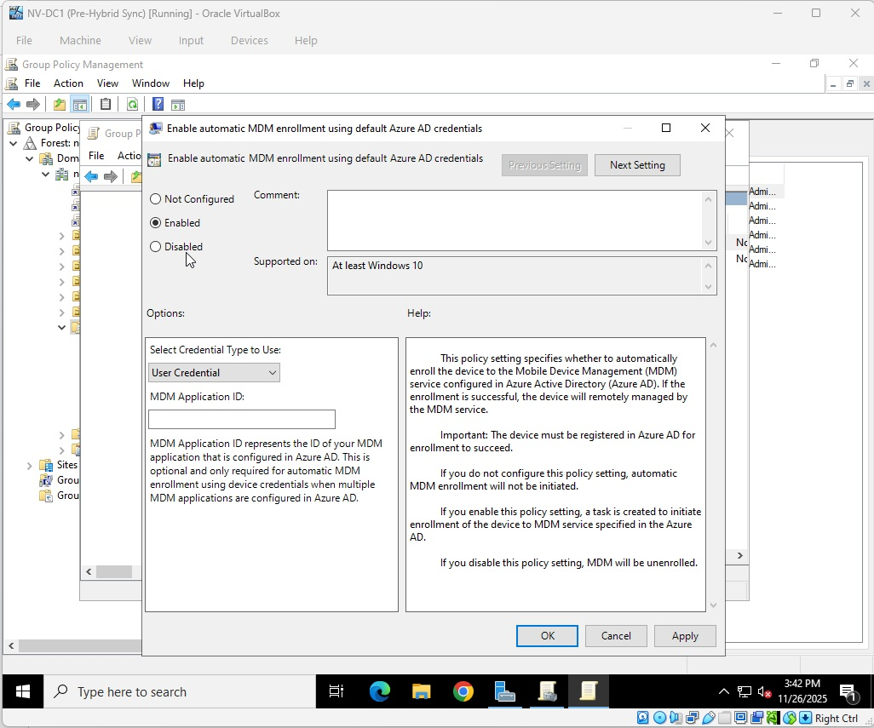

- Evidence 3: Screenshot of gpupdate /force executed on NV-CLI.
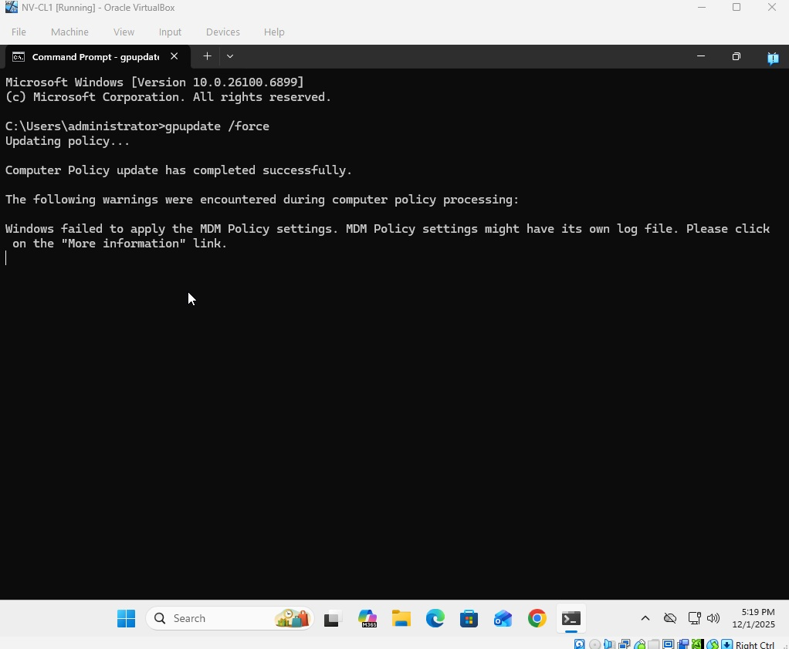

Task 2— Hybrid Azure AD Join & Intune Enrollment Validation

(10 pts)
NV-CLI was validated to confirm successful Hybrid Azure AD Join and Intune MDM enrollment. These verification steps ensure the device is correctly registered and managed through cloud policies.
Required Evidence
- Evidence 4: Screenshot of dsregcmd /status showing AzureAdJoined: YES.
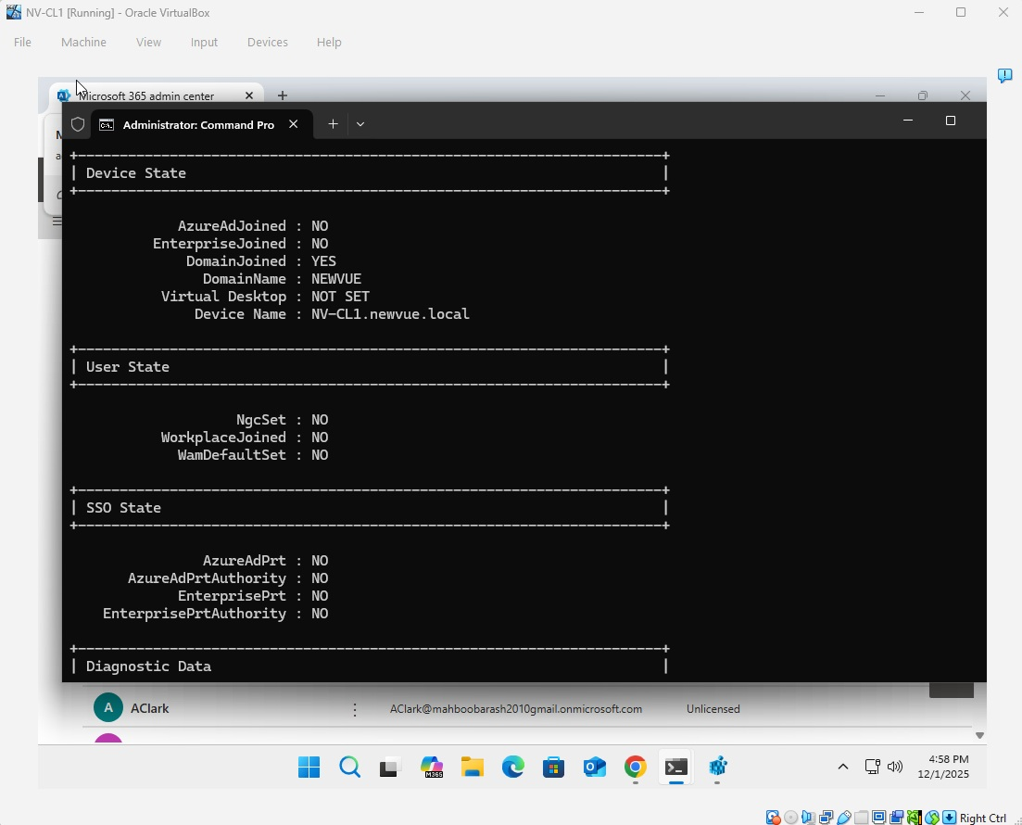

- Evidence 5: Screenshot of NV-CLI listed under Devices → All devices in Intune.
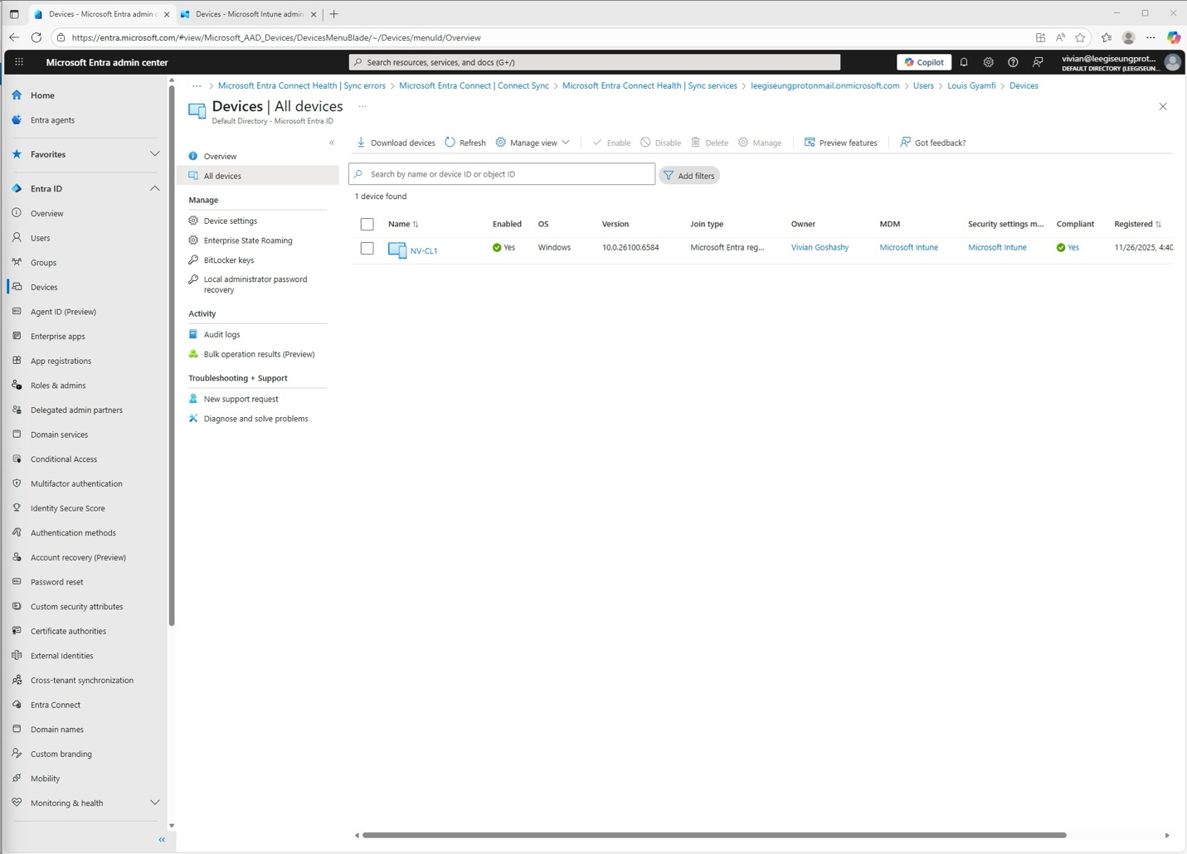

Task 3— Microsoft 365 (Office) Deployment (10 points)
Microsoft 365 Apps were deployed to NV-CLI using Intune application management.
This demonstrated cloud-based application delivery and modern software deployment workflows.
Required Evidence
- Evidence 6: Screenshot of the Microsoft 365 Apps deployment configuration.
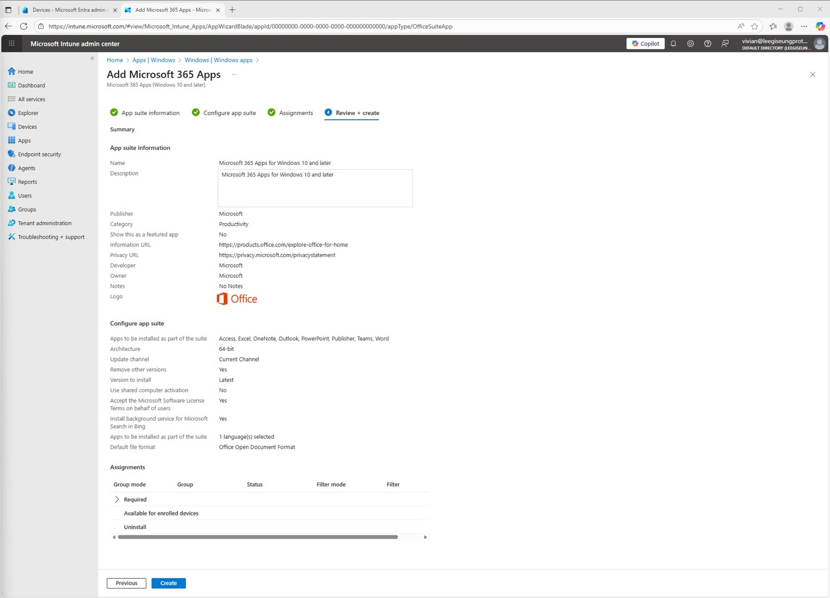

- Evidence 7: Screenshot of Office applications appearing on NV-CLI.
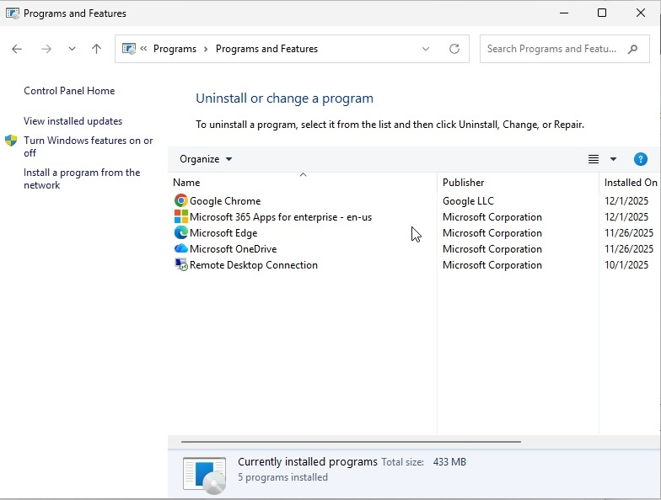

Task 4 - Compliance Policies & Security Baseline (20 pts)
A compliance policy and Microsoft Security Baseline were applied to NV-CLI to enforce organizational security requirements.
These policies demonstrate how cloud-managed devices are governed by centralized controls.
Required Evidence
- Evidence 8: Screenshot of the Compliance Policy assignment.
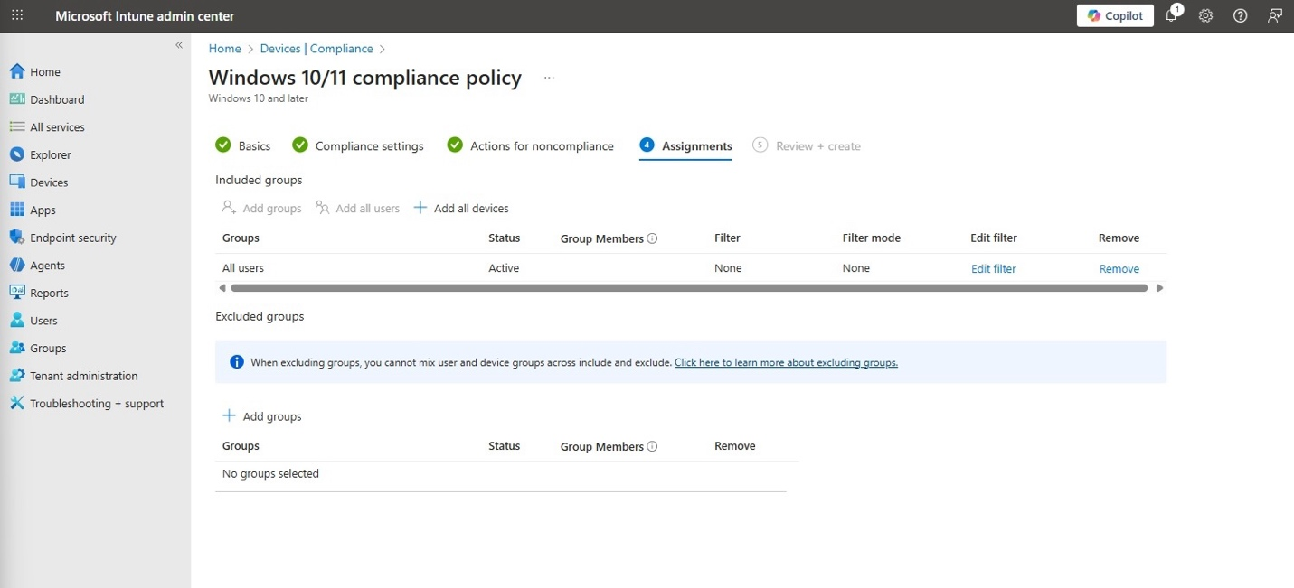

- Evidence 9: Screenshot of NV-CLI compliance status.
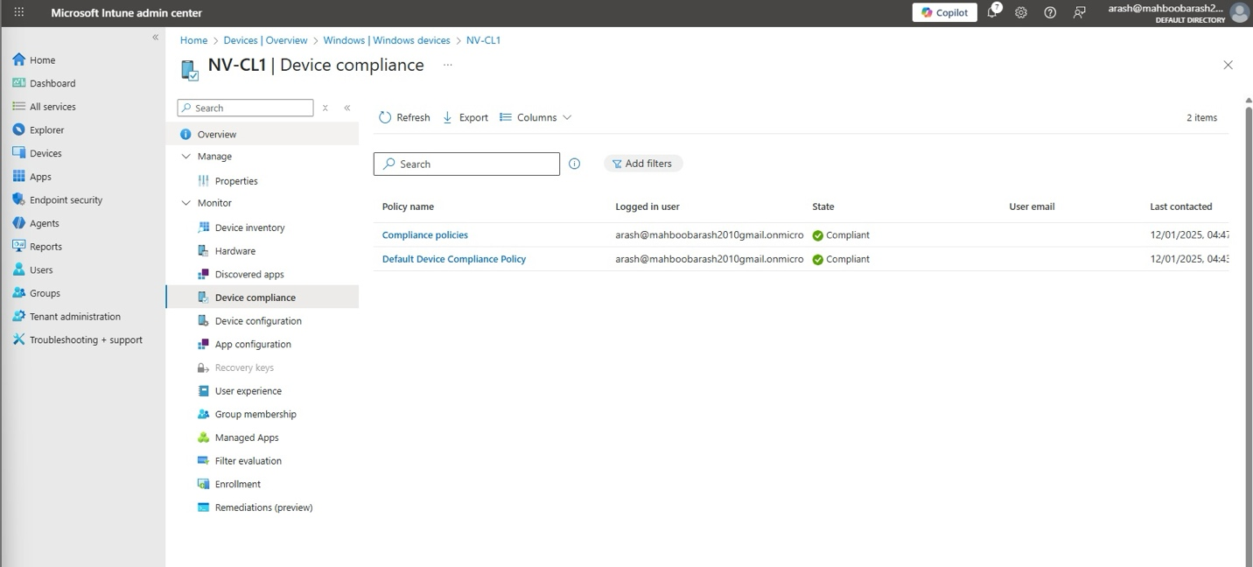
- Evidence 10: Screenshot of NV-CLI Security Baseline status in Intune.
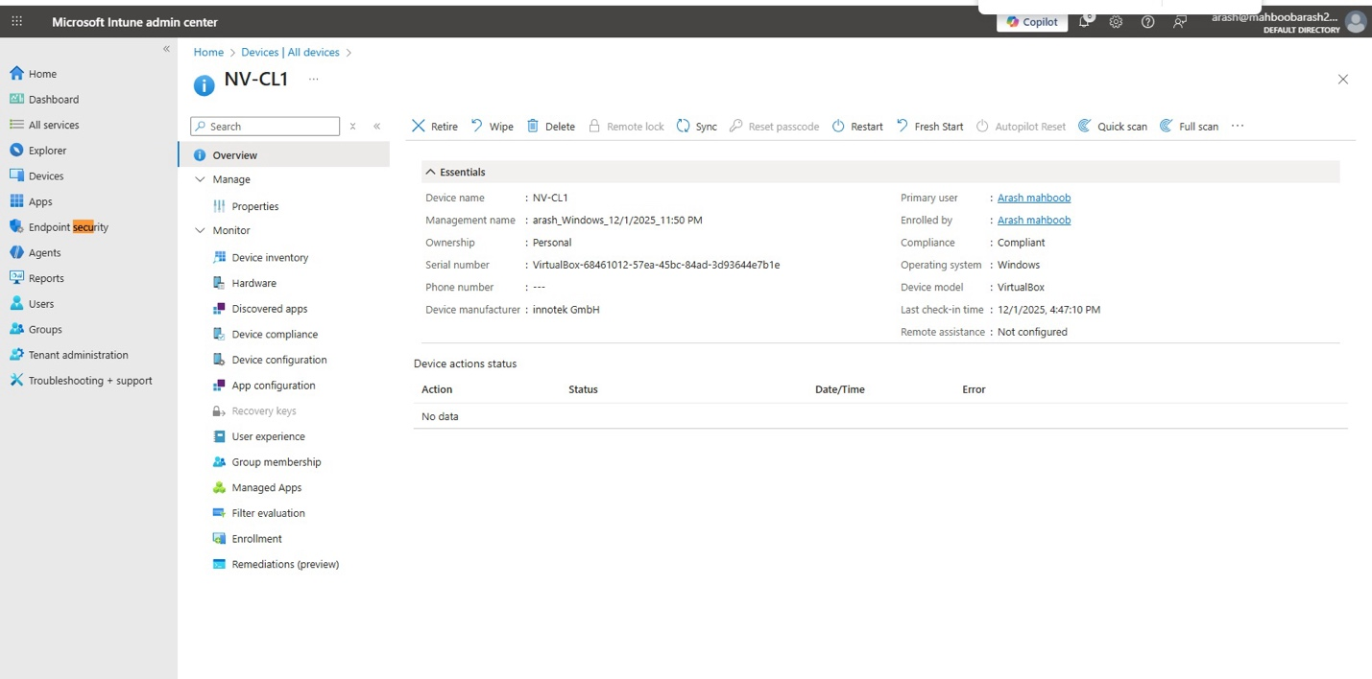
- Evidence 11: Screenshot of relevant registry paths showing applied baseline settings.
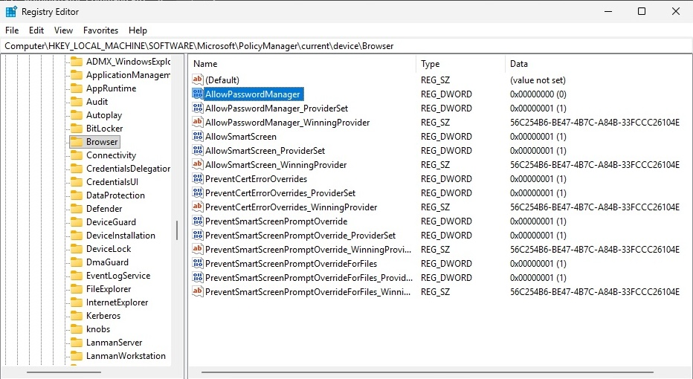

Task 5 - Windows Update Ring Configuration (5 pts)
A Windows Update Ring was created and assigned to devices to control how feature and quality updates are delivered.
This ensures predictable update behavior across hybrid-managed devices.
Required Evidence
Evidence 12: Screenshot of the Update Ring configuration summary.
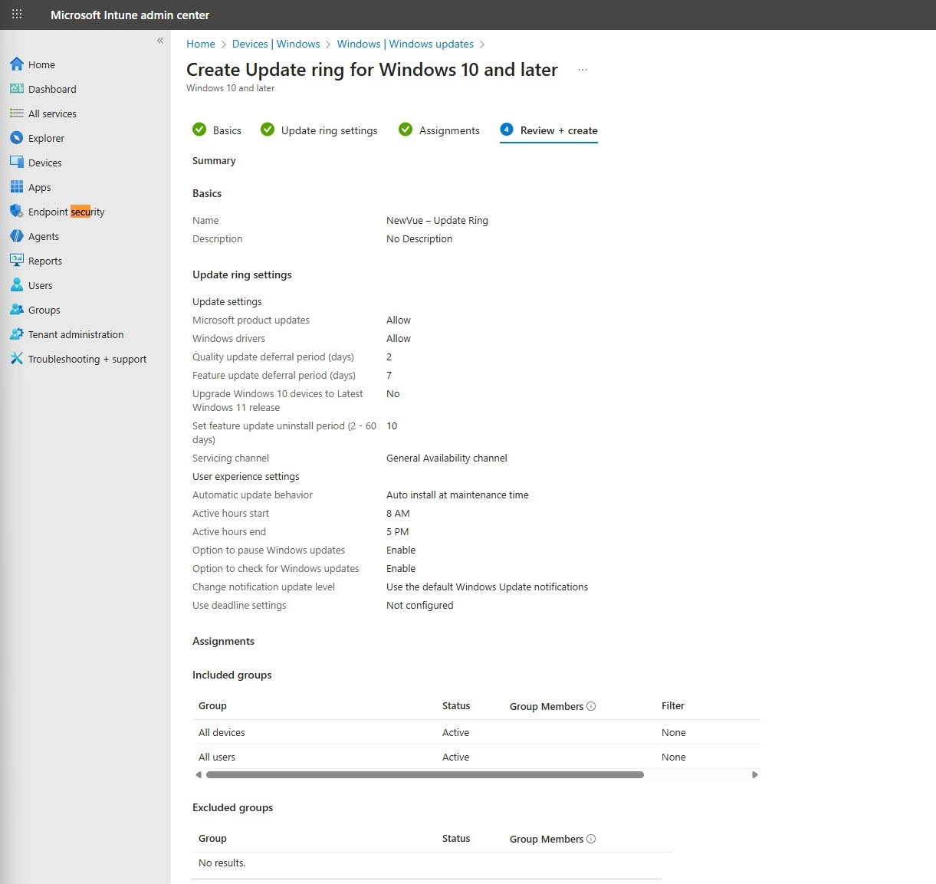

Task 6 - Remote Device Actions (10 pts)
Basic remote management actions were executed from the Intune Admin Center, such as Sync or Restart.cThis demonstrates remote control and cloud-based management capabilities.
Required Evidence
Evidence 13: Screenshot of the available Remote Actions for NV-CLI.
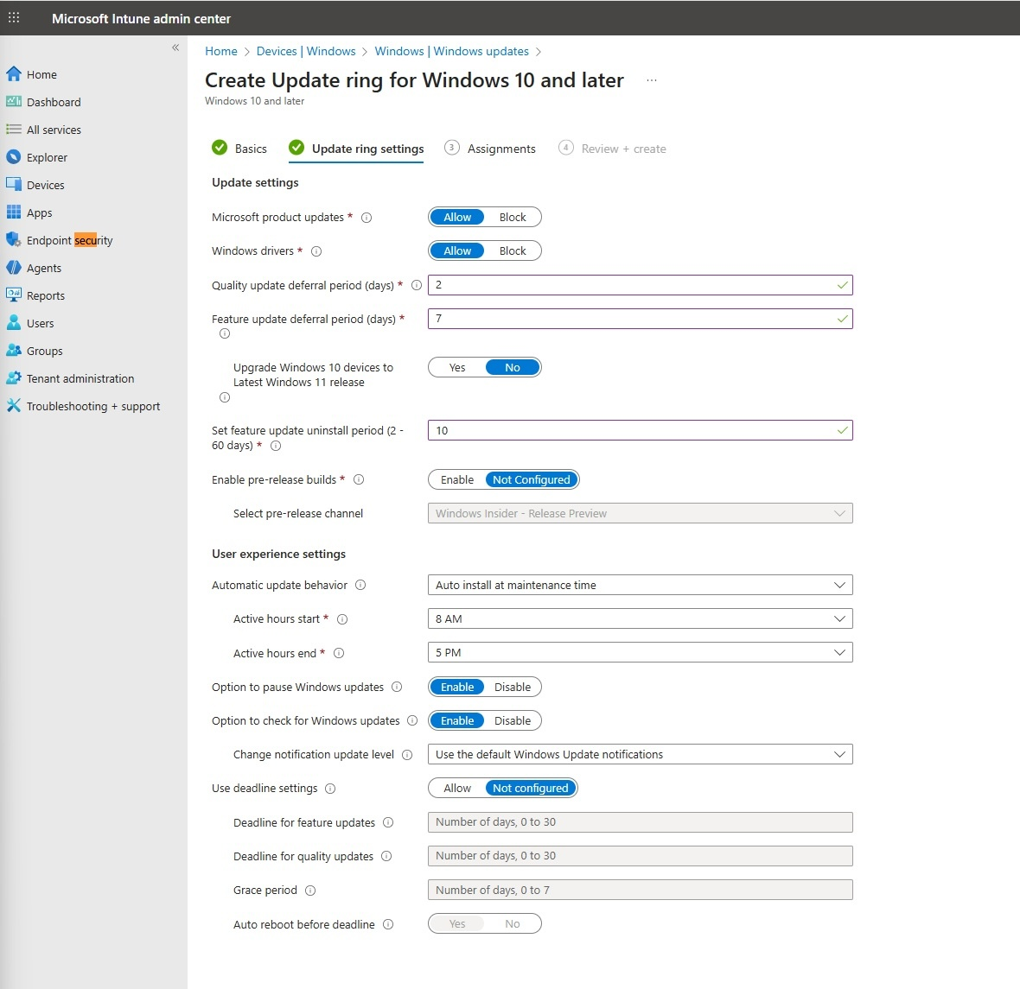

Evidence 14: Screenshot confirming execution of one action (e.g., Sync completed).
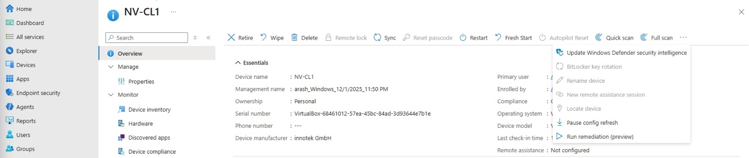

Task 7 - Device Reporting & Hardware Inventory (10 pts)
Intune reporting features were reviewed to confirm device health, hardware information, and compliance details.
This ensures administrators can accurately track device state and configuration.
Required Evidence
Evidence 15: Screenshot of the Hardware information page for NV-CLI.
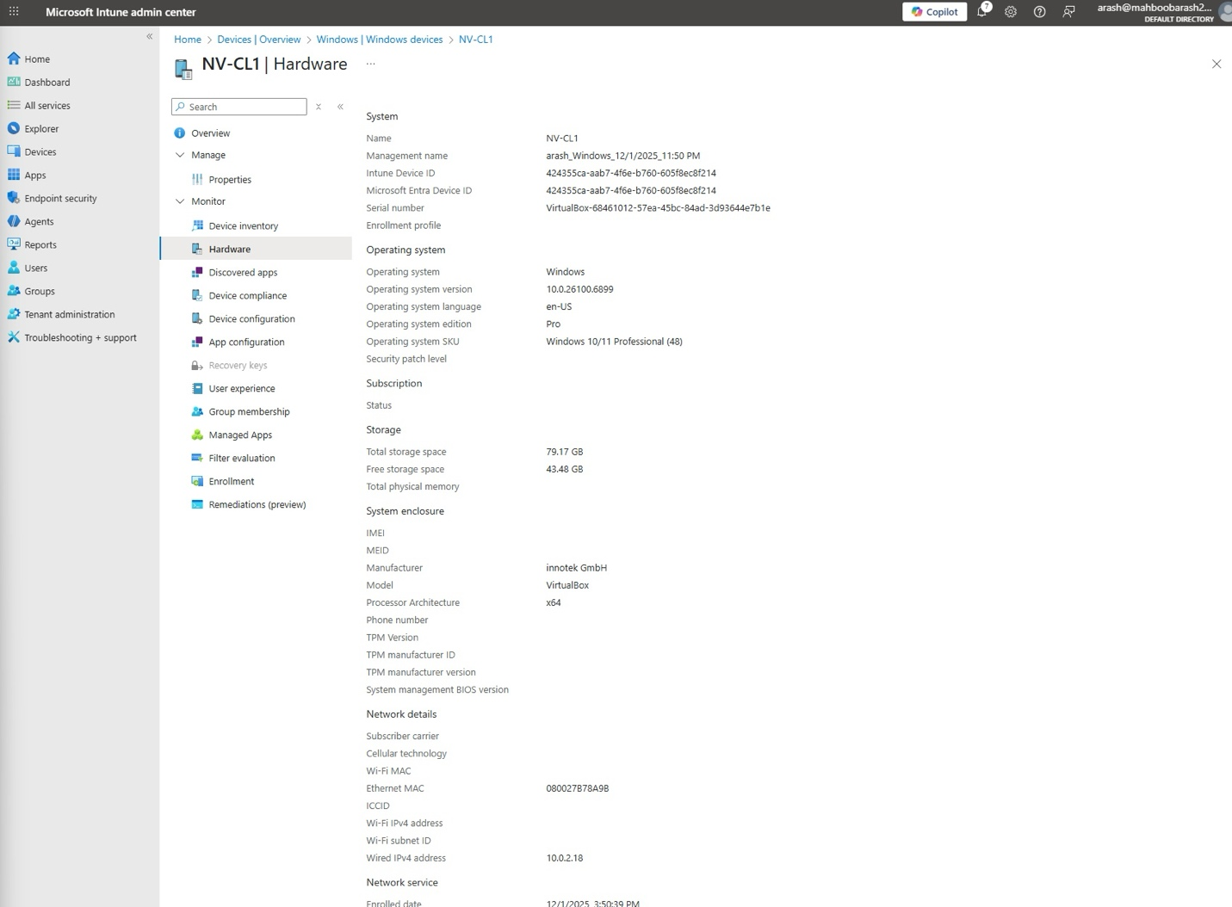

Evidence 16: Screenshot of the Device Compliance overview for NV-CLI.

